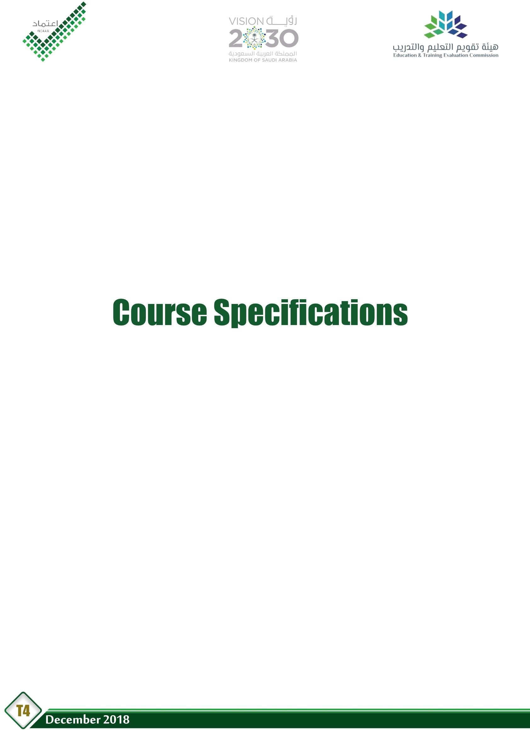

Course Title: | Discrete Mathematics
Course Code: | 283MATH-3
Program: | Computer Science + Information System
Department: | Computer Science + Information Systems
College: | Computer Science and Information Systems
Institution: | Najran University

Table of Contents
- Course Identification 3
6. Mode of Instruction (mark all that apply) 3
- Course Objectives and Learning Outcomes 4
  - Course Description 4
  - Course Main Objective 4
  - Course Learning Outcomes 4
- Course Content 4
- Teaching and Assessment 5
  - Alignment of Course Learning Outcomes with Teaching Strategies and Assessment Methods 5
  - Assessment Tasks for Students 5
- Student Academic Counseling and Support 5
- Learning Resources and Facilities 6
  - Learning Resources 6
  - Facilities Required 6
- Course Quality Evaluation 6
- Specification Approval Data 7

2

Course Identification

1. Credit hours:
2. Course type
a. | University | College |  | √ | Department |  |  |  |  | Others
b. | Required | √ | Elective
3. Level/year at which this course is offered: |  |  |  |  |  |  |  | 4 | / 2
4. Pre-requisites for this course (if any):
5. Co-requisites for this course (if any): Non

- Mode of Instruction (mark all that apply)
No | Mode of Instruction | Contact Hours | Percentage
1 | Traditional classroom | 3 | 100%
2 | Blended | --- | ---
3 | E-learning | --- | ---
4 | Correspondence | --- | ---
5 | Other | --- | ---

- Actual Learning Hours (based on academic semester)
No | Activity | Learning Hours
Contact Hours
1 | Lecture | 45
2 | Laboratory/Studio | ---
3 | Tutorial | ---
4 | Others (specify) | ---
 | Total | 48
Other Learning Hours*
1 | Study | 30
2 | Assignments | 15
3 | Library | 10
4 | Projects/Research Essays/Theses | ---
5 | Office hours | 10
 | Total | 110

* The length of time that a learner takes to complete learning activities that lead to achievement of course learning outcomes, such as study time, homework assignments, projects, preparing presentations, library times

3

Course Objectives and Learning Outcomes
1. Course Description
This course introduces Numbers system, Logic: Conjunctions, logical equivalence and arguments; Methods of proofs, Sets, operations on sets, Cartesian products. Relations: Equivalence relations, Order relations, Functions, Counting principles, Permutations and Combinations. It also covers Trees: Tree diagrams, Types of trees, Graphs: Undirected graphs, Directed graphs, Adjacency matrix for directed graph, Planar graphs, and Isometry.
2. Course Main Objective
Understanding numbers systems; Logic: Conjunctions, logical equivalence and arguments; Methods of proofs. Sets, operations on sets, Cartesian products. Know relations: Equivalence relations, Order relations, Functions, Counting principles, Permutations and Combinations. Recognize trees: Tree diagrams, Types of trees. Finally, Understand graphs: Undirected graphs, Directed graphs, Adjacency matrix for directed graph, Planar graphs, Isometry.

3. Course Learning Outcomes
CLOs |  | Aligned PLOs
1 | Knowledge:
1.1 | Describe mathematical structures and to distinguish between them.
1.2 | Know methods of mathematical proof and graphs(plans) and their types.
1...
2 | Skills :
2.1 | Explain how students apply the relationships and logic diagrams (data).
2.2 | Determine the types of relationships and graphs and methods of proofs.
2.3
2...
3 | Competence:
3.1 | Work effectively with in groups and independently
3.2 | Apply critical thinking, communication skills and mathematical techniques in solving many problems .
3.3
3...

Course Content
No | List of Topics | Contact Hours
1 | Numbers systems | 6
2 | Logic: Conjunctions, logical equivalence and arguments; Methods of proofs. | 6
3 | Sets, operations on sets, Cartesian products. Relations: Equivalence relations, Order relations, Functions | 12
4 | Types of trees, Graphs: Undirected graphs, Directed graphs, Adjacency matrix for directed graph, Planar graphs, Isometry. | 9
5 | Counting principles, Permutations and Combinations, Trees: Tree diagrams and Binomial theorem. | 12
...

4

Total
45

Teaching and Assessment

Alignment of Course Learning Outcomes with Teaching Strategies and Assessment Methods
Code | Course Learning Outcomes | Teaching Strategies | Assessment Methods
1.0 | Knowledge
1.1 | Describe mathematical structures and to distinguish between them. | - Lecture  - Discussions | - Quiz  - Written Exam
1.2 | Know methods of mathematical proof and graphs(plans) and their types. | - Lecture  - Discussions | - Quiz  - Written Exam
… | --- | --- | ---
2.0 | Skills
2.1 | Explain how students apply the relationships and logic diagrams (data). | - Identify induced sub graphs, and proper sub graphs | - Lecture  - Discussions
2.2 | Determine the types of relationships and graphs and methods of proofs. | - Solve problems involving first and second fundamental  forms. | - Lecture  - Discussions
… | --- | --- | ---
3.0 | Competence
3.1 | Work effectively with in groups and independently | - Solve exercises through individual work and groups.  - Lectures,  discussion | - Solving exercise  - Oral Exam
3.2 | Apply critical thinking, communication skills and mathematical techniques in solving many problems
… | --- | --- | ---

Assessment Tasks for Students
# | Assessment task* | Week Due | Percentage of Total Assessment Score
1 | Exercises, Homework& Assignments | Open | 10%
2 | Oral Exam and Rubrics | 14th Week | 5%
3 | Quizzes | Open | 5%
4 | Written Test(1) | 7th Week | 15%
5 | Written Test(2) | 13th Week | 15%
6 | Final Exam | End of Semester | 50%
*Assessment task (i.e., written test, oral test, oral presentation, group project, essay, etc.)

Student Academic Counseling and Support
Arrangements for availability of faculty and teaching staff for individual student consultations and academic advice :
- Introducing the course syllabus, grading scale and the distribution of marks for the course in the first lecture of the course.
- Arrangements for availability of teaching staff for individual student consultations and academic

advice (include amount of time teaching staff are expected to be available each week).
  - Office hours for a teaching staff for one hour weekly.

Learning Resources and Facilities

Learning Resources
Required Textbooks | - K. H. Rosen, Discrete Mathematics and its Applications, McGraw- Hill, 5th Edition (2004).
Essential References Materials | - S. S. Epp, Discrete Mathematics with Applications, PWS-Cant Pub. Co., 1990.  - L. Lesniak, Discrete Structures, Logic, and Computability, Jones and Bartlett.
Electronic Materials | - Richard Johnsonburg, Discrete Mathematics, Prentice Hall, 6th Edition (2004).  - K. Devlin, Sets, Functions and Logic, Chapman and Hall, (1995).
Other Learning Materials | - Matlab software

Facilities Required
Item | Resources
Accommodation  (Classrooms, laboratories, demonstration rooms/labs, etc.) | Lecture Hall by the number of seats = 30 seat approximately.
Technology Resources  (AV, data show, Smart Board, software, etc.) | - Datashow  - Smart Board  - Wi Fi
Other Resources  (Specify, e.g. if specific laboratory  equipment is required, list requirements or attach a list) | - None

Course Quality Evaluation
Evaluation Areas/Issues | Evaluators | Evaluation Methods
Student course evaluation survey at the end of semester. | Students | Questionnaire (Indirect)
Effectiveness of teaching and assessment | Peer Reviewer | Rubrics (Indirect)
--- | --- | ---
--- | --- | ---
--- | --- | ---
--- | --- | ---
--- | --- | ---
Evaluation areas (e.g., Effectiveness of teaching and assessment, Extent of achievement of course learning outcomes, Quality of learning resources, etc.)
Evaluators (Students, Faculty, Program Leaders, Peer Reviewer, Others (specify)

6

Assessment Methods (Direct, Indirect)

Specification Approval Data
Council / Committee | Department Council
Reference No. | Session No. 10 (441-38-43300)
Date | 17/2/2020

7

