المملكة العربية السعودية
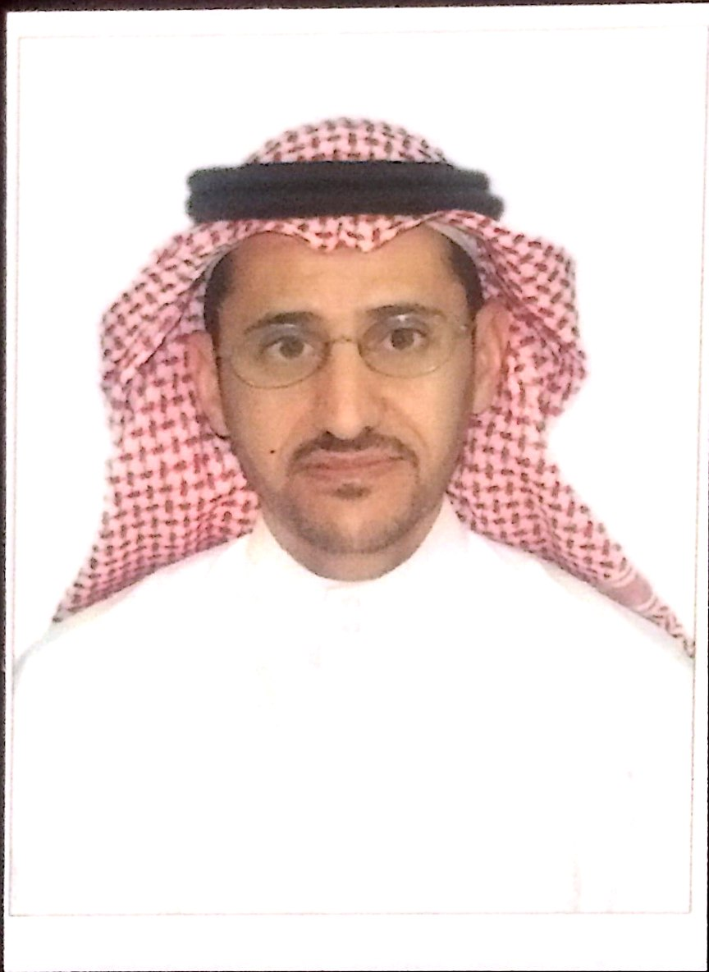
وزارة التعليم
جامعة نجران
كلية العلوم والاداب بشرورة
Biography
General Information
Name | Hathal obaid aiad alfehaidi | Department | Education and kindergartens
Staff position | Assistant Professor | Nationality | Saudi
Phone | 0553300092 | Email | hoalfehaidi@nu.edu.sa
Specialization | Education | Area of Specialization | Curriculum and methods of teaching science

Education History
Certificate | Date | Country | University | Study Them | Note
Ph.D | 1433 | K.S.A | Um -Alqura | On campus
Master | 1424 | K.S.A | Um -Alqura | On campus
bachelor | 1416 | K.S.A | King Abdulaziz | On campus
Scientific Grade
Title | Date | Country | University | Study Them | Note
Assistant Professor | 2014 | K.S.A | Najran | On campus
Teaching Courses
Course Nam | Teaching Year | Note
Curriculum basics | 1435-1436
Teaching Methods | 1435-1436
Educational Supervision | 1435-1436
Environmental Education | 1435-1436-1437-1438-1439
Education and Society | 1437-1438-1439
educational administration | 1437
communication skills | 1436

